Cross Rhyme

🔹 What is Cross Rhyme
# Source: Chatgpt (GPT-4-turbo) at [8/2/2025]
⚠️ Cross rhyme is a rhyme scheme, not a type of homograph. However, homographs may appear in cross rhyme if their pronunciation fits the pattern.

✅ Definition of Cross Rhyme
# Source: Chatgpt (GPT-4-turbo) at [8/2/2025]
Cross rhyme refers to a rhyming pattern in a four-line stanza (quatrain) where the first and third lines rhyme, and the second and fourth lines rhyme.
👉 It follows the ABAB rhyme scheme.

🧠 Key Features
# Source: Chatgpt (GPT-4-turbo) at [8/2/2025]
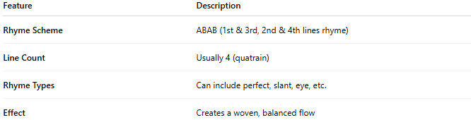
Feature | Description
Rhyme Scheme | ABAB (1st & 3rd, 2nd & 4th lines rhyme)
Line Count | Usually 4 (quatrain)
Rhyme Types | Can include perfect, slant, eye, etc.
Effect | Creates a woven, balanced flow

📝 Example of Cross Rhyme (ABAB):
# Source: Chatgpt (GPT-4-turbo) at [8/2/2025]
A: The wind was harsh across the land
B: The leaves were torn and sky turned gray
A: It struck the hills with unseen hand
B: Then vanished fast and blew away
- land / hand (A lines rhyme)
- gray / away (B lines rhyme)
✅ This is a cross rhyme.

🧪 Using Homographs in Cross Rhyme
# Source: Chatgpt (GPT-4-turbo) at [8/2/2025]
Homographs can appear at the ends of rhyming lines in ABAB form if their pronunciation matches. Examples:
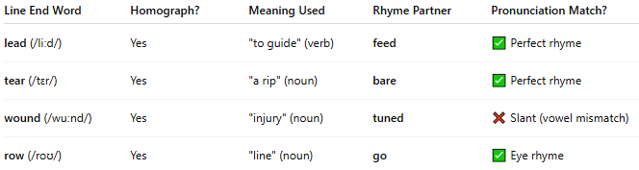
Line End Word | Homograph? | Meaning Used | Rhyme Partner | Pronunciation Match?
lead (/liːd/) | Yes | "to guide" (verb) | feed | ✅ Perfect rhyme
tear (/tɛr/) | Yes | "a rip" (noun) | bare | ✅ Perfect rhyme
wound (/wuːnd/) | Yes | "injury" (noun) | tuned | ❌ Slant (vowel mismatch)
row (/roʊ/) | Yes | "line" (noun) | go | ✅ Eye rhyme
🗣️ Caution: Homographs like wind, tear, lead, etc., only rhyme when the pronunciation is controlled.

✅ Summary
# Source: Chatgpt (GPT-4-turbo) at [8/2/2025
- Cross rhyme = a quatrain with ABAB rhyme scheme
- Homographs can be used in cross rhyme if their pronunciation fits
- Allows perfect, slant, eye, or assonance rhymes
- Often used in formal poetry, ballads, and lyrics

